CYNGOR CYMUNED DYFFRYN ARDUDWY A TALYBONT
DYFFRYN ARDUDWY & TALYBONT COMMUNITY COUNCIL

GWASANAETH SUL Y COFIO GER Y GOFEB
REMEMBRANCE SERVICE BY WAR MEMORIAL

11EG TACHWEDD 2018 AM 3.00 Y PRYNHAWN
NOVEMBER 11TH 2018 AT 3.00 P.M.

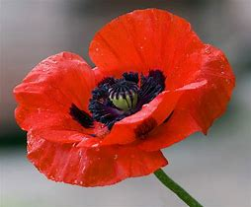

CROESO CYNNES I BAWB
WARM WELCOME TO EVERYONE

